
Touchstones Project Faith in Action
In-Reach / Out-Reach / Justice-Making

Renewal

Contents
1.0: Introduction
1.1: Introduction
2.0: Observances
2.1: Spring Festival/Chinese New Year, January 31 / February 1, 2022
3.0: Resources/Activities
3.1: Chinese New Year Resources
3.2: Memories of the New Year by Jiarui Zhang

Resources & Activities
1.0: Introduction
The New Year is marked at different times by different religions and cultures. The fact that January 1st begins the New Year in the Gregorian solar calendar is more a result of political and religious influences than other considerations. The earth, however, is closest to the sun in early January, an event which is called Earth’s perihelion. The distance is 3 million miles closer than at the farthest point, which is called the aphelion.

The city of Babylon in ancient Mesopotamia was where the first New Year’s celebrations were recorded about 2000 BCE. The Babylonians, who used a lunisolar calendar, held their New Year celebrations on the first new moon after the vernal equinox, i.e., March 20-21. They called this festival Akitu, which comes from the word the Sumerians used for barley. It lasted 12 days and was the time when they begin to harvest barley.

Others, like the ancient Egyptians, Phoenicians, Persians, began the new year with the autumnal equinox, i.e., September 22-23.

There have also been changes in what marks the new year. As an example, during the First Temple period (8th to mid-6th century BCE) in Judaism, the year began in the spring, on the first day of Nisan (i.e., March–April). It is not clear when Rosh Hashanah began to be observed, now celebrated as the Jewish New Year on the first day of the fall month of Tishrei (September-October). Information, however, about Rosh Hashanah as the “New Year” was included in the Mishnah around 200 CE.

New Years in China also has an interesting history. When Sun Yat-sen founded the Republic of China on January 1, 1912, he declared that China would begin to follow the Gregorian calendar rather than their traditional lunisolar calendar. This suggested that China might have two New Year’s days, a solar new year and a lunar new year. Rather than calling January 1st New Year Day, however, they decided to call it Yuandan (i.e., “the first sunrise”). Unfortunately, this had been the name of the first day of the lunar New Year, which begins on the new moon that appears between January 21st and February 20th. In place of Yuandan, they began calling the lunar New Year celebration the “Spring Festival,” which lasts 15 days until the Lantern Festival. This year, the Spring Festival, which will usher in the Year of the Tiger, will begin on February 1st. New Year’s Eve will be January 31st when extended families gather for dinner.

Traditionally, China has used an ancient lunisolar calendar, on which the Chinese New Year is based. It existed as early as 14th century BCE, when the Shang Dynasty (aka Yin dynasty) was in power. The calendar features 24 solar terms or periods (see below) based on the sun’s position in the zodiac and guides agricultural affairs and farming activities. Each solar term lasts about 15 days and is decided by the position of the sun in the sky. Spring begins with the term or period called Lichun, when the sun reaches the celestial longitude of 315° and ends when it reaches the longitude of 330°. It means that it will slowly begin to get warmer.

In thinking about renewal, the Chinese New Year/Spring Festival is worth observing since it points the way toward the springtime.

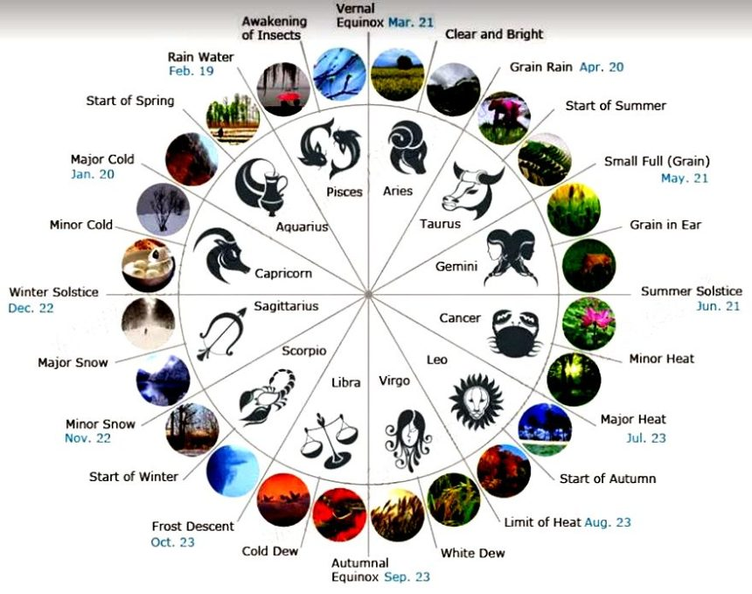

2.0: Observances
2.1: Spring Festival/Chinese New Year, January 31-Eve / February 1, 2022-Day
This is the year of the Tiger. It is the year 4719 in the Chinese calendar.
3.0: Resources/Activities
3.1: Chinese New Year Resources
See Chinese New Year: Tiger Year, 7 Foods, 6 Traditions, 18 Taboos at https://www.chinahighlights.com/travelguide/special-report/chinese-new-year/
3.2: Memories of the New Year by Jiarui Zhang
In this time of the year, all the people are getting busy, everyone will buy new clothes, by the influence of the elders, think that New Year must buy new clothes and wear new clothes to celebrate the New Year, and only in this way can show the New Year new atmosphere.
I was young at the time, so all I need to do are responsible for buying new clothes and waiting for everyone to sit down at the dinner table. we have fish, pork, beef, duck, vegetables, and all kinds of seafood in front of the table. After eating, we will eat some fruit, because we eat at the door so we can watch the moon. Of course, after eating the fruit is a program that all of our children like, is to say congratulations and fortune so they will give you a red envelope. We don’t care how much money is in the red envelope, because not only our family members give us the red envelope. I was living in a village at that time, so I could go from door to door and say congratulations to them, and then they would give you red envelopes. The why I can do this just because I am a child, but not adults! Unlike Halloween in the United States, both children and adults can get candy at the door.
On the day before the Spring Festival, we will invite the elders to write the Spring Festival couplets or draw New Year pictures, so that we can put the written Fu on the door, of course, you don’t have to ask the elders to write, you can go to the store to buy. (Tell you an interesting thing: if the children go to the store to buy something and then say to the boss inside happy New Year, then they will also give you red envelope!)

